**Project Design Phase-II**

**Technology Stack (Architecture & Stack)**

|  |  |
| --- | --- |
| Date | 28 June 2025 |
| Team ID | LTVIP2025TMID49487 |
| Project Name | House hunt: finding your perfect rental home |
| Maximum Marks | 4 Marks |

**Technical Architecture:**

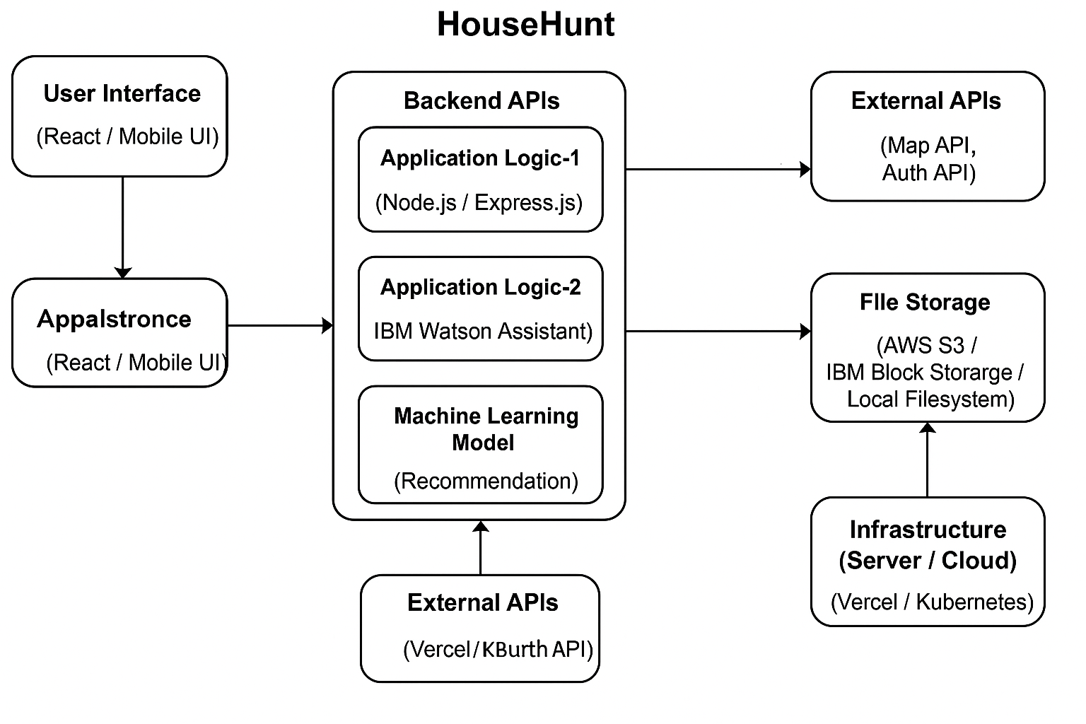

**Table-1 : Components & Technologies:**

|  |  |  |  |
| --- | --- | --- | --- |
| **S.No** | **Component** | **Description** | **Technology** |
|  | User Interface | Frontend web/mobile UI. | HTML, CSS, JavaScript, React.js |
|  | Application Logic-1 | Backend business logic for user/property ops | Node.js / Express.js |
|  | Application Logic-2 | Text-based search and recommendation engine | Python + Scikit-learn |
|  | Application Logic-3 | |  | | --- | | Conversational assistant (future enhancement) |  |  | | --- | |  | | IBM Watson Assistant (optional) |
|  | Database | Stores user, property, booking info | MongoDB (NoSQL) |
|  | Cloud Database | Cloud-hosted DB | MongoDB Atlas / IBM Cloudant |
|  | File Storage | Property images / documents | AWS S3 / IBM Block Storage / Local FS |
|  | External API-1 | Location/Map-based search | Google Maps API |
|  | External API-2 | Government ID verification (optional) | Aadhaar e-KYC API |
|  | Machine Learning Model | Property recommendation engine | Python (Scikit-learn / TensorFlow Lite) |
|  | Infrastructure (Server / Cloud) | Cloud deployment environment | Vercel (Frontend), Heroku / Render (BE), Kubernetes (Optional) |

**Table-2: Application Characteristics:**

| **S.No** | **Characteristics** | **Description** | **Technology** |
| --- | --- | --- | --- |
|  | Open-Source Frameworks | Frontend and backend libraries and tools | React.js, Express.js, Node.js, MongoDB |
|  | Security Implementations | Access control, data protection, API security | JWT Auth, HTTPS, bcrypt , CORS, OWASP |
|  | Scalable Architecture | Tiered architecture with cloud support for scale | 3-tier with load balancer and microservices |
|  | Availability | High availability using distributed cloud hosting | Cloud Load Balancer, Multi-Region MongoDB |
|  | Performance | Optimized REST APIs, Lazy loading, CDN for assets, Cache for search | Redis (optional), CDN (Cloudflare), Axios |

**References:**

[**https://c4model.com/**](https://c4model.com/)

[**https://developer.ibm.com/patterns/online-order-processing-system-during-pandemic/**](https://developer.ibm.com/patterns/online-order-processing-system-during-pandemic/)

[**https://www.ibm.com/cloud/architecture**](https://www.ibm.com/cloud/architecture)

[**https://aws.amazon.com/architecture**](https://aws.amazon.com/architecture)

[**https://medium.com/the-internal-startup/how-to-draw-useful-technical-architecture-diagrams-2d20c9fda90d**](https://medium.com/the-internal-startup/how-to-draw-useful-technical-architecture-diagrams-2d20c9fda90d)